  - Joint Letter from Stakeholders Across the Permanent Removals Value Chain to SBTi Regarding the Corporate Net-Zero Standard Version 2.0 (Second Public Consultation Draft)
  - November 2025

Empowering companies to reach their net zero targets using permanent carbon removals
The undersigned companies and organisations stand united in their commitment to contribute responsibly and effectively towards achieving the global climate goals. We strongly urge the Science Based Targets initiative (SBTi) to ensure that the forthcoming net-zero standard promotes – rather than restricts – companies’ and nations’ ability to make carbon removals part of reaching their net zero targets.
To this end, we call for targeted amendments of the draft standard such that it enables or at the very least does not hamper efforts by companies and nations to co-fund removal projects and to employ climate accounting based on a dual-ledger approach. Removals generated within the scope of NDCs or compliance mechanisms should be eligible for use towards company neutralization claims, under the Ongoing Emission Responsibility recognition framework as well as towards company net zero targets. Such mechanisms would allow both nations and businesses to account for the climate outcomes in their respective and separate climate target systems, thus accelerating the growth of durable carbon removal solutions essential for achieving net-zero – globally and across SBTi members and other companies.
Addressing uncertainty around eligibility of permanent carbon removals for neutralization claims
On 6 November, the SBTi issued the second consultation draft for its forthcoming Corporate Net-zero Standard version 2.0.
Without prejudice to individual consultation responses on a wider range of questions arising from the draft, the undersigned companies and organisations have united in emphasising the critical importance of amending the current draft’s wording on:
(1) double counting and corresponding adjustments, as defined in the main document, item CNZS-C29.6, and
(2) additionality, as defined in the Annex E Illustrative integrity principles for neutralization at the net-zero target year, item 1.3.
With the current wording, SBTi would create uncertainty around the eligibility of carbon removals for neutralization claims, consequently making the attainment of net-zero by its members and nations prohibitively costly or even impossible for the former. Ultimately, the current wording will not support the required climate action – on the contrary, it will hinder progress and prove detrimental to the climate.
Taking the wider view: Ensuring permanent CDR scale-up is possible within the broader SBTi framework
The current wording does not adequately consider the circumstances for permanent carbon removals. Scaling the permanent removals industry to the necessary gigatonne levels is one of the most challenging aspects of reaching net-zero and limiting temperature increase to 1.5°C above pre-industrial levels. Building a new industry is hard, with learnings and efficiencies only materializing over generations of projects. The number of companies that have reached Final Investment Decisions (FID) remains limited, mainly due to lack of clarity and incentives for CDR, and many of the FIDs rely on government aid which presupposes that the removals will also be accounted for under NDCs.
A fast growth of permanent removal projects is required to ensure that on-going emission reductions can eventually be complemented by cost-efficient permanent removals to counterbalance the hard-to-abate emissions. This need was recently emphasized by Johan Rockström in connection with COP30, where he notes that a “massive scaling of CDR” is required.
There is broad consensus that the required scaling will be virtually impossible to achieve without extensive private-public partnerships in the ramp-up and capacity-building phases of the CDR industry. To reach scale, these partnerships are based on co-funding and a dual-ledger accounting approach where host nations aggregate the mitigation outcomes of corporations on their territories, just the same way emission reductions are treated.
The co-funding, leveraging government aid to attract corporate purchases, can only work if, on the one hand, taxpayers’ money can contribute to national climate objectives and, on the other hand, corporations can attain climate goals and make neutralization claims based on their purchases. This mirrors how co-funding works for emission reduction projects.
Raising ambitions by allowing co-funding for permanent CDR
The argument, sometimes advanced within the context of Article 6, that the action of corporations could lower the ambition of governments might be correct for low-cost credits but does not apply to high-cost permanent removals. To the contrary, the co-funding/dual-ledger approach is driving increased ambitions for permanent removals, allowing more companies to reach FID, enabling more projects, more tonnes, and more learnings. Also, it has the potential to free up public funds for other mitigation activities. Consequently, the concern of lowering ambitions due to historical experience from low cost ”traditional carbon credits” with often more ambiguous climate effects, should not be used as a blueprint when developing a framework for the use of permanent carbon removals in making corporate claims.
The co-funding/dual-ledger approach is, for permanent removals, almost by default additional since it combines private and public funding to support under-funded projects that would not have happened otherwise. None of the recent FIDs in large permanent removal projects would have happened without the approach. For example, Sweden, Norway, Denmark, UK, and Switzerland all assume this structure. This is also the case of the EU Carbon Removal and Carbon Farming (CRCF) framework.
Relying on the Polluter Pays Principle, it is also important to recognize that at the point of net-zero, corporate accounts and national accounts should have the same permanent removals to counterbalance hard-to-abate emissions. Thus, the limitation of CNZS-C29.6 even appears difficult to reconcile with the notion of net-zero.
Mandated use of removals must be reflected in the net-zero state for companies
Mandated removals will be part of many countries’ NDCs. If a company is mandated to acquire removals to counterbalance its emissions, those removals must be eligible for use also towards SBTi targets. If not, SBTi companies would in such circumstances be expected to buy two tonnes of removals for every tonne to counterbalance to reach net-zero.
Even though supporting the Global South and investing in that region are hugely important objectives, as well as bridging the gap between countries’ pledged commitments and the actual need for climate mitigation, these goals should be pursued through appropriate instruments or incentives. Tweaking a fundamental, economy-wide dual ledger framework to address these objectives – such as introducing requirements where public and private joint funding is deemed differently depending on geography or to require corresponding adjustment for permanent removals used by corporates for neutralization claims - will create inconsistencies and undermine the system’s effectiveness. The other important objectives (e.g. closing ambition gap and channelling funds to Global South) should be addressed through other means.
Amending the SBTi Net Zero Standard to enable delivery on corporate net zero targets
Counting towards one NDC and one company’s account is not double counting. Against this background, and with a view to ensure the broadest possible support for the SBTi NZ V2.0 standard, the following amendments (in red) are requested:
C29.6. Double counting and corresponding adjustments: Removals used for neutralization shall not be simultaneously claimed by another entity corporation for compliance or voluntary or NDC accounting purposes. Where removals are authorized for use under Article 6 of the Paris Agreement, a corresponding adjustment by the host country shall be demonstrated. In the absence of such adjustment, The activity may only be reported as a contribution under the Ongoing Emissions Responsibility recognition framework as well as for neutralization., not as neutralization
On page 96 of the draft, we find that there is good wording to ensure additionality for voluntary projects and purchases. We therefore propose the following amendments to ensure that the definition of additionality is compatible with the proposal above, and properly indicates what is the purpose of the corresponding adjustment:
1.3. Additionality: The outcome would not have occurred without the intervention. This generally means showing that activities are not already financially viable, legally mandated, or fully financed under existing policies. Neutralization avoid creating barriers to investment in lower-income countries, activities can be aligned with, or contribute toward, a host country’s Nationally Determined Contribution (NDC), provided there is credible evidence that voluntary company support is additional enables mitigation beyond what is already funded or committed under existing policies and measures and for ITMO transactions it can be demonstrated that corresponding adjustments, under Article 6 of the Paris Agreement, have been applied by the host country to avoid double counting between nations.
***
In conclusion, we are asking for:
- A revision of paragraph C29.6 to reflect that a corporate can make a neutralization claim based on a permanent carbon removal certificate if it is not simultaneously claimed by another company for compliance or voluntary purposes, while ensuring that the removal is included in no more than one NDC.
- An amendment of the definition of Additionality in point 1.3 to make it possible for neutralization activities to contribute toward a host country’s NDC provided there is proof of additionality for voluntary applications and corresponding adjustments have been applied when ITMO transactions are involved.
We are committed to engaging with the SBTi secretariat to help enable its members to reach their climate ambitions using permanent carbon removals as a complement to emission reductions, whilst safeguarding environmental integrity. We would encourage all corporate actors and CDR value chain actors to include this letter and its content in their submissions.
Sincerely yours,

Initiated by:


Supported by:


























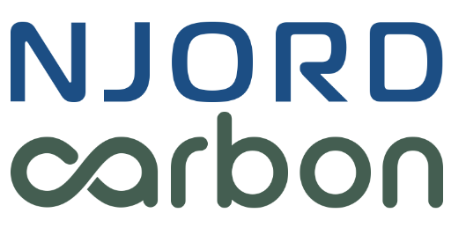












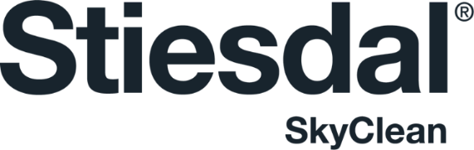





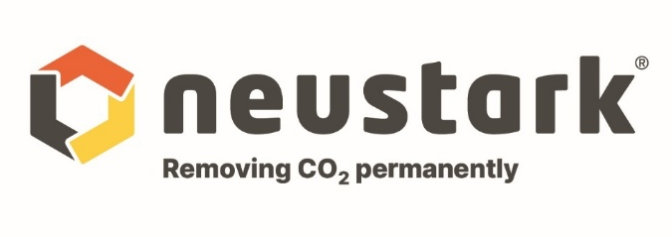

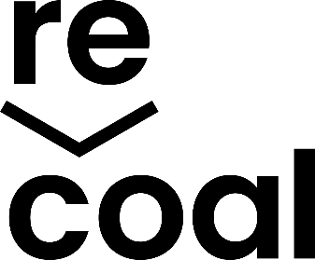











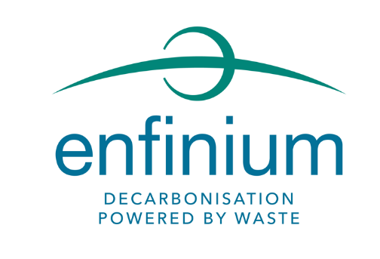

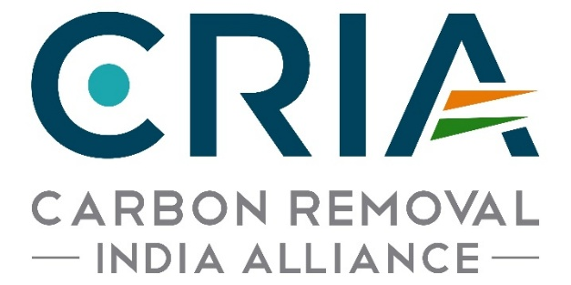

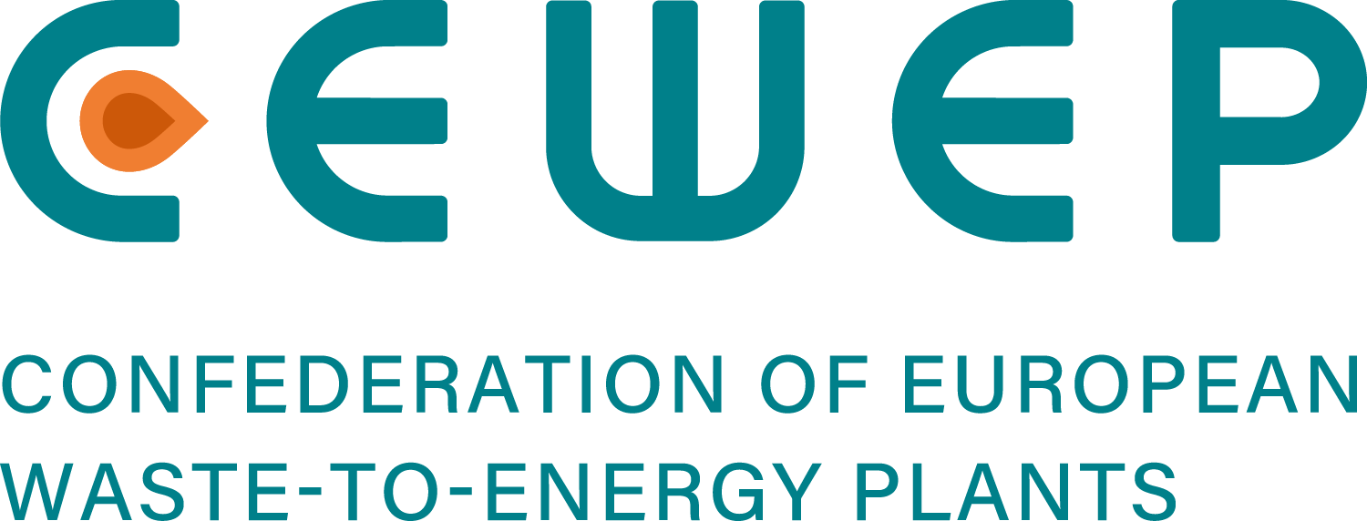


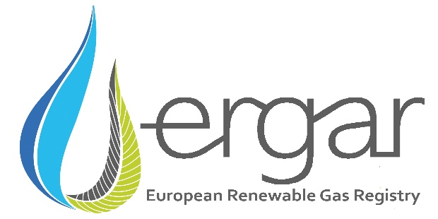

The dual-ledger approach consists of viewing national climate accounting and corporate climate accounting as two separate systems, where the national ledger by default aggregates the mitigation outcomes on the corporate level, be it emissions or removals. In a voluntary application of removals, this implies that a host country can account for removals on its territory while the removal certificate can be sold to a corporation domiciled either in the country or in another nation, as long as that nation does not count the removal in its national accounting.
https://www.linkedin.com/pulse/what-science-tells-every-negotiator-cop30-johan-rockstr%C3%B6m-gx1pf/
https://www.smithschool.ox.ac.uk/sites/default/files/2025-06/Neutralisation_Claims_in_the_Era_of_Article_6_OxSFG_Working_Paper.pdf

